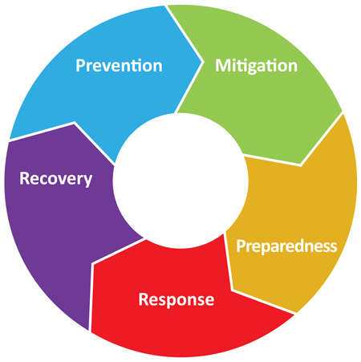Emergency Management Process

Preparedness is a process; it begins with measures to prevent emergencies and any activities to mitigate the risk. Observance and deterrents would fall into this. A neighbourhood watch program would be one way to be prepared, raising an alert where appropriate. Measures to mitigate risk include training and exercises to be ready to respond to events. Preparedness is having the protocols and action plans in place. Responding to an event, it’s critical to know who’s doing what and how to function. This is not the time to decide. After the crisis has passed it’s imperative to have a process in place to rebuild and resume functioning.